**How successive wars crippled Indian economy**

As things are getting tense at the border, lets dig into history to get some insights about the effects of war on our economy. As we all know, India was forced into a war by Pakistan in 1965, hoping to take advantage of India's defeat at the hands of China. However, India managed to win both the wars that followed. But , was the winning side discounted from loses? The answer is probably no.

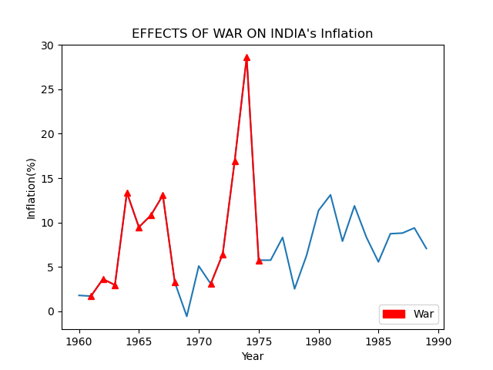

From the plot, we can clearly see how India's inflation rose drastically from mere 1% in 1961 to 13% during a period of 5 years. After the war in 1971 against Pakistan, Inflation increased again and touched a sky high of 30% in 1974 which is an all time record. The GDP annual growth was no different and followed a negative trend which clearly indicates economic crisis at the time.

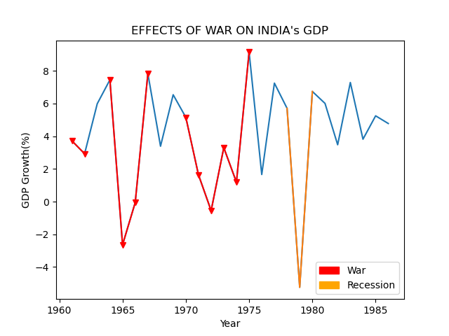

GDP shrank by 3% in 1965. There was no time for recovery as both sides clashed again in 1971. Inflation rose whereas, GDP saw negative trend again. Even after winning both the wars, our economy suffered for more than 10 years which lead to poverty, unemployment and malnutrition. Looking at the current developments, one cannot deny the possibility of another war. What’s worse is that, this time it could be a two front situation. So what do you think? Can India afford another war?

References

<https://data.worldbank.org/>

<https://www.wikipedia.org/>